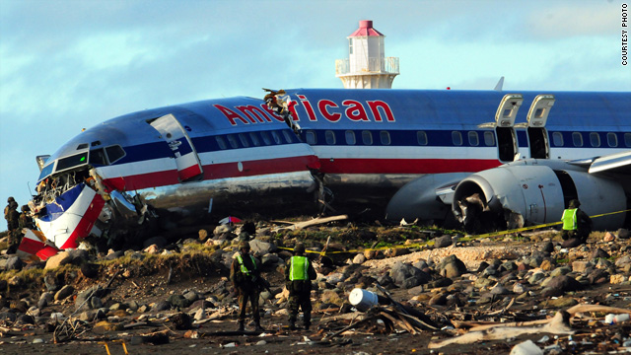CIS 5270 Project

Analysis of Airplane Crashes and Fatalities Since 1908

By -:

Atinder Paul Singh

305091298

Table of Contents

A) Data Set URL’s 3

B) Data Cleaning 4

C) Data Visualization 7

D) Dashboard 14

E) Story Telling 15

|  |  |
| --- | --- |
| This topic includes the following data: - | |
| Date: | Date of accident, in the format - January 01, 2001 |
| Time: | Local time, in 24 hr. format unless otherwise specified |
| Airline/Op: | Airline or operator of the aircraft |
| Flight #: | Flight number assigned by the aircraft operator |
| Route: | Complete or partial route flown prior to the accident |
| AC Type: | Aircraft type |
| Reg: | ICAO registration of the aircraft |
| cn / ln: | Construction or serial number / Line or fuselage number |
| Aboard: | Total aboard (passengers / crew) |
| Fatalities: | Total fatalities aboard (passengers / crew) |
| Ground | Total killed on the ground |
| Summary | Brief discussion of the accident and causes if known |

## Data Set URL’s

This was created into a dataset by Airplanes Crashes Since 1908 (Sauro Grandi, 2016, <https://www.kaggle.com/saurograndi/airplane-crashes-since-1908> ).

## Data Cleaning

Category 1) Missing Values: Removal of non-useful columns.

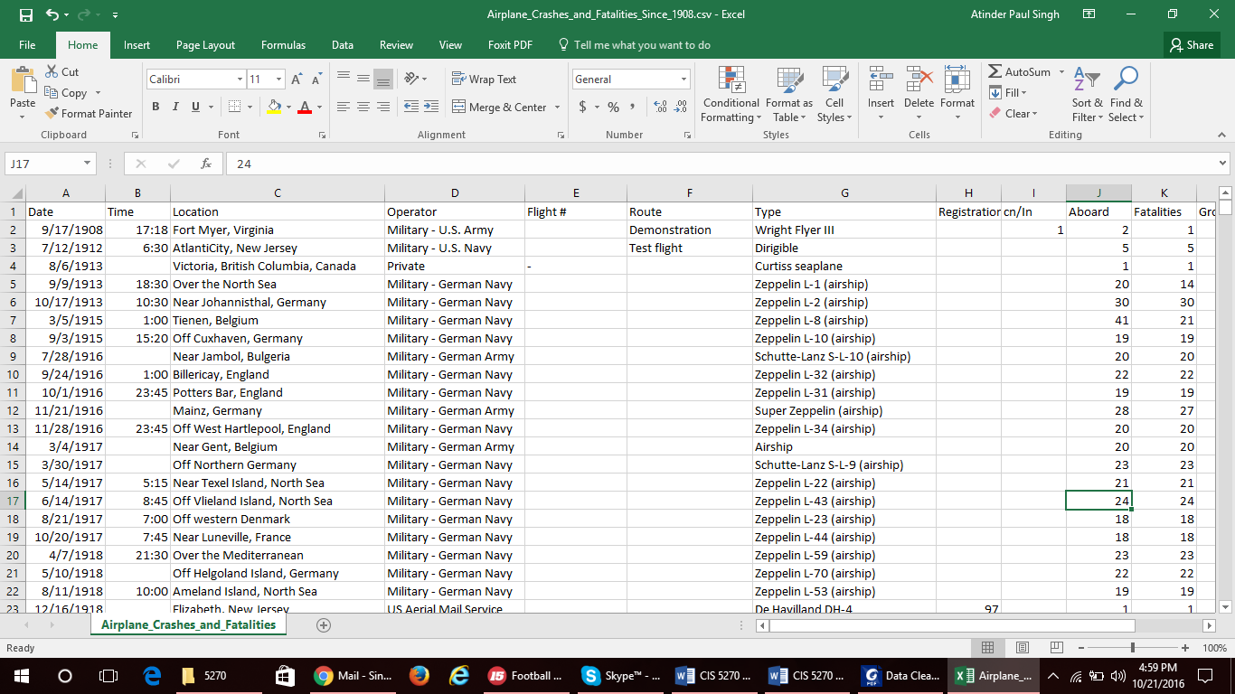 Before.

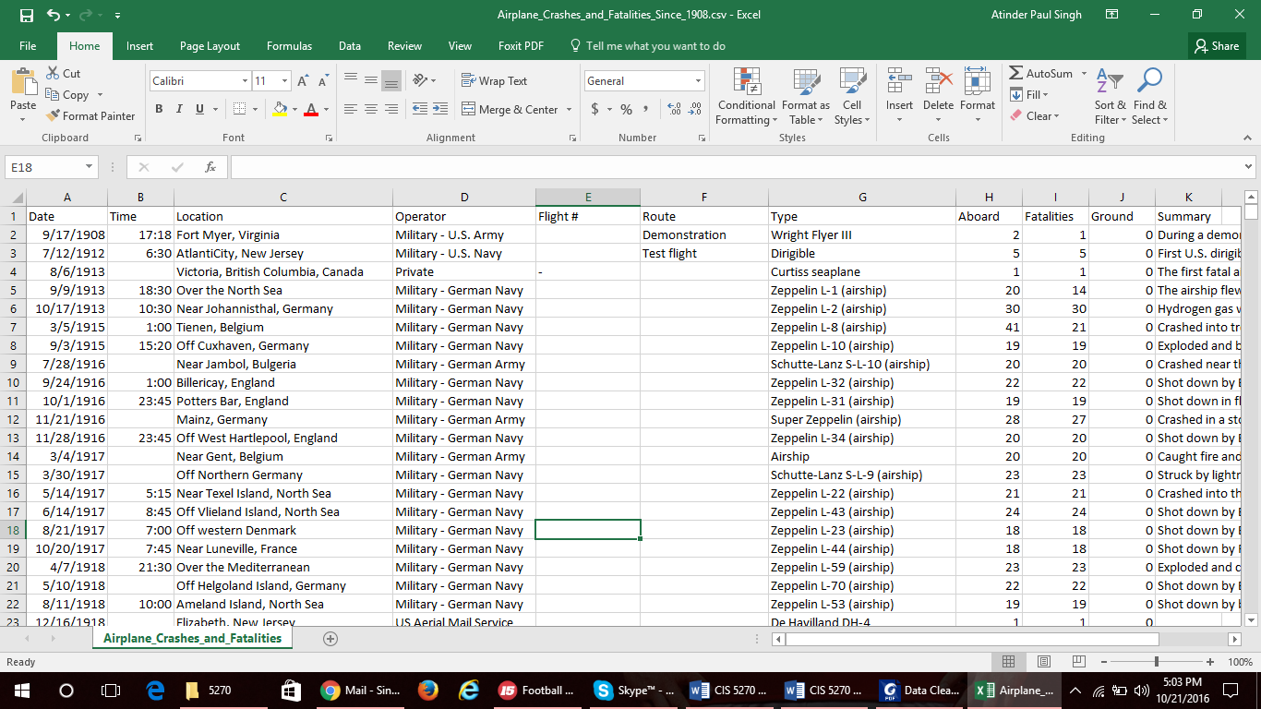After

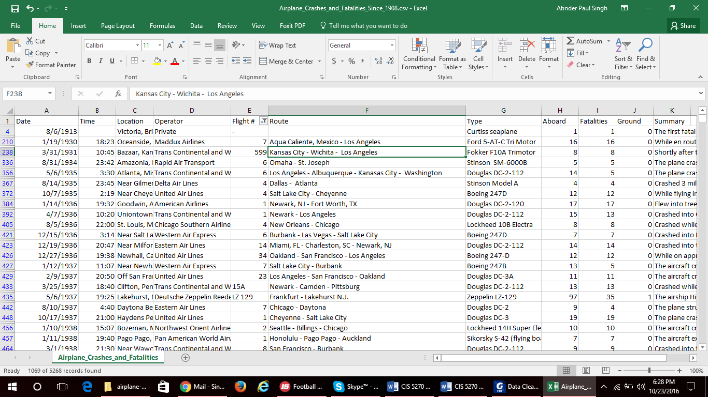Category 2) Illegal Values: Already Clean.

Category 3) Contradicting Values: Already Clean.

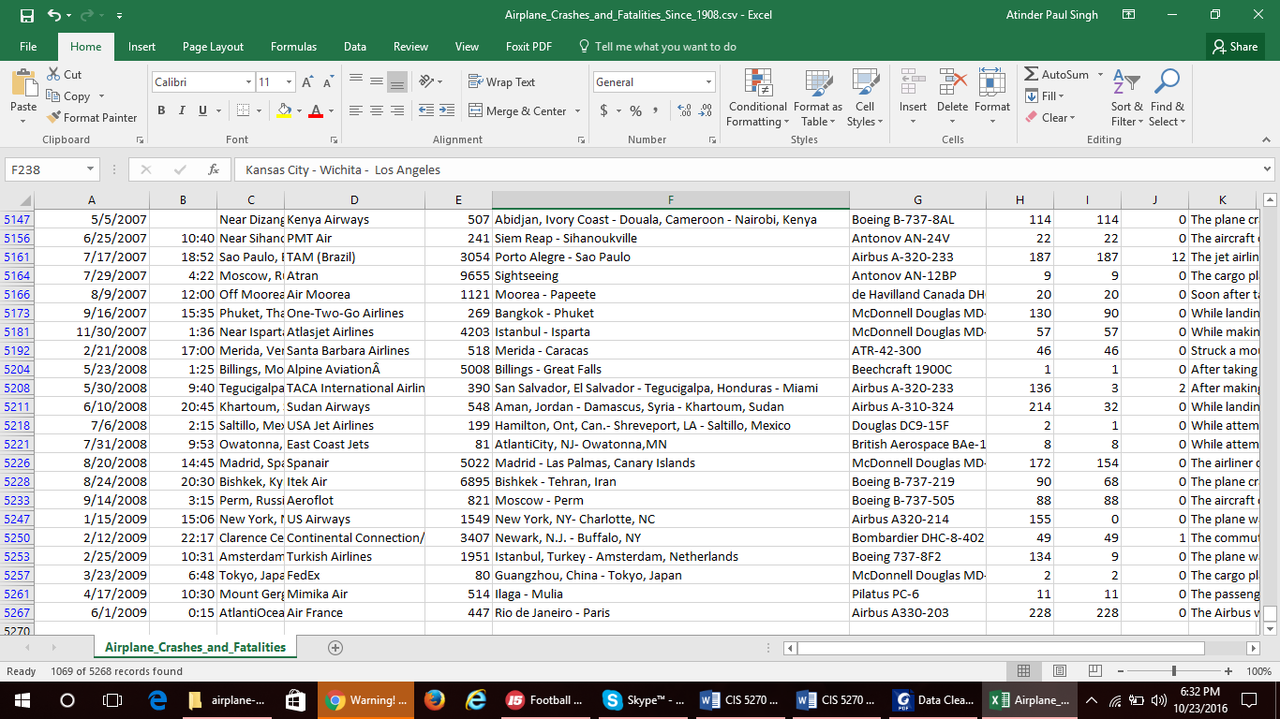Category 4) Uniqueness Violation: Already Clean.

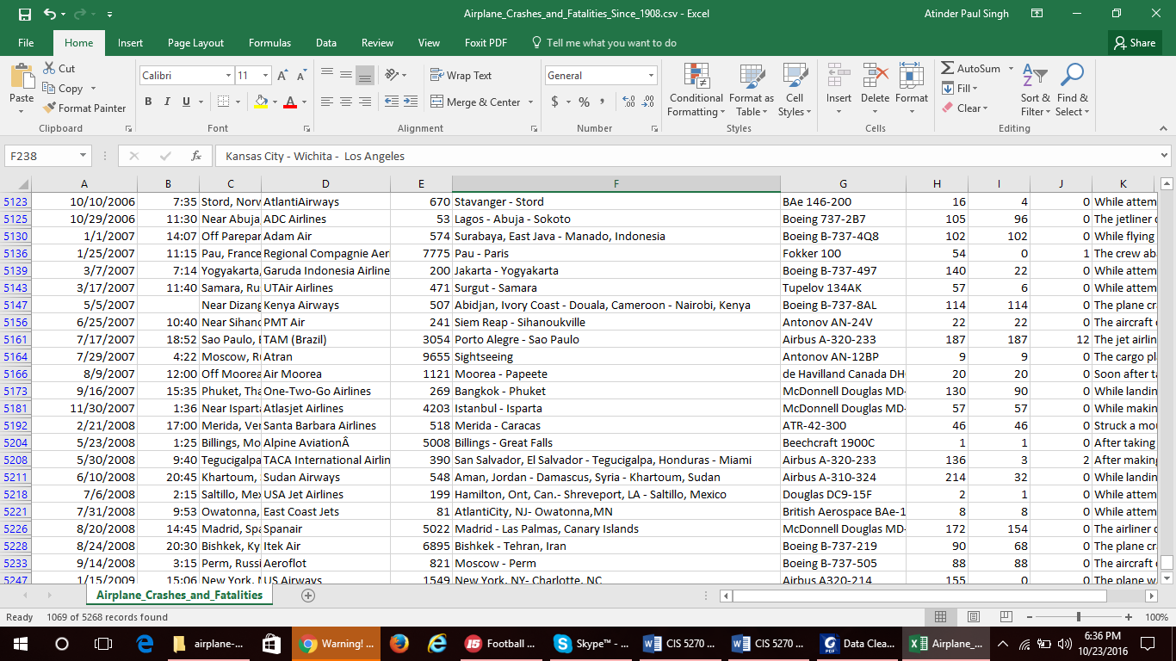Category 5) WrongReferences: Already Clean.

## Data Visualization

1. 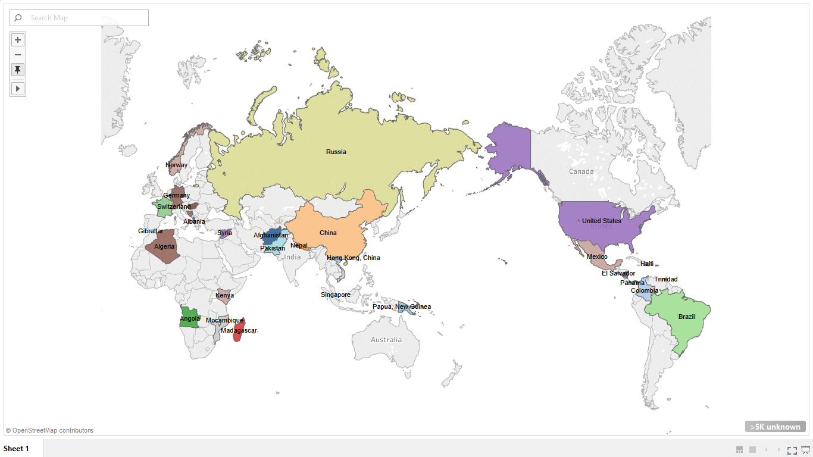Which of the countries encountered the crashes?

In the first visualization of the project, we are analyzing the crashes of different countries as in how many crashes have happened in which country. As in the early 90’s Russia and United States had a lot of countries under them, hence the map shows a lot of Russia and US locations. Through the map we can understand that Russia had large amount of airplane crashes. Small towns like Madagascar, Trinidad, Angola and different other countries too encountered large amount of airplane crashes.

1. 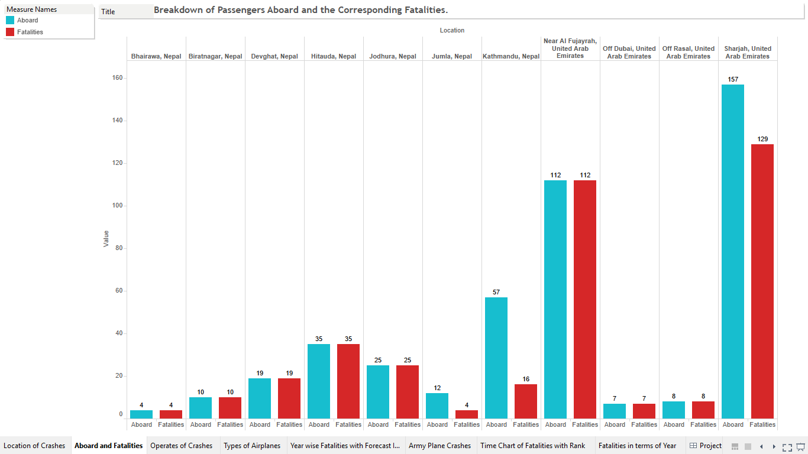How many people were aboard on the airplane and how many fatalities had occurred in United Arab Emirates and Nepal?

In the second visualization of the project, we have taken 2 Countries namely United Arab Emirates and Nepal and compared the passengers/crew that were aboard and the passengers/crew that were unfortunately the fatalities in the crash. By just the above analyzation it seems that airplane crash is pretty brutal and does not leave much trace after it. In support of the above argument Expect Sharjah, UAE and Kathmandu with Jumla, Nepal other places in the area had 100% casualty percentage to the people boarding the flight.

1. Who were the operates of the crashed airplanes in taking consideration of how may deaths occurred on the ground impact?

In the third visualizations of the project, we analyzed which operate/airline was the cause of ground deaths, that maybe due to any kind of ground explosions or after landing mishaps. We can identify that Aeroflot the Russian airlines have had the most ground deaths and next comes the U.S Air Force Military planes followed by Air France Lufthansa etc. Due to any reasons we can conclude that Aeroflot had the maximum crashes in terms of ground causalities.

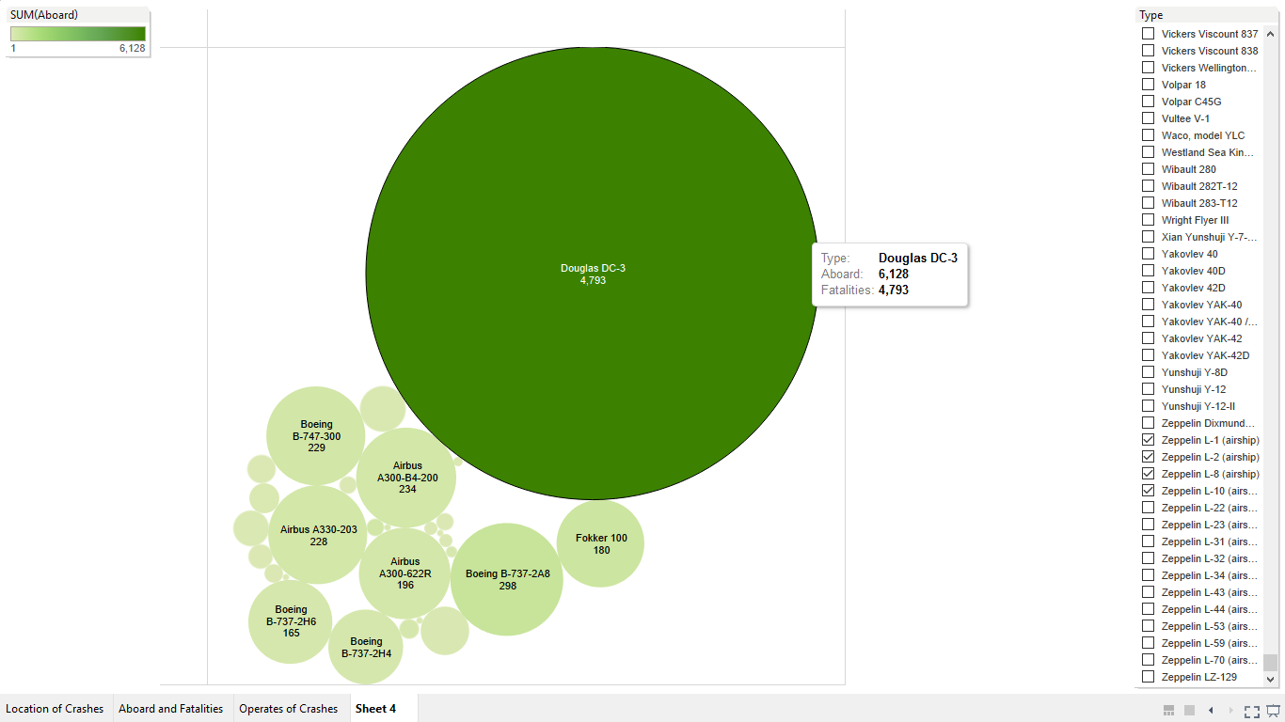4) Which types of airplanes crashed?

In the fourth visualization of the project, we have gathered great insight on the types of airplanes that encounter crashes. According to the packed bubbles chart here we have shown the passengers/crew aboard and fatalities to the same in which the size is the fatalities and the color shades are the passengers/crew aboard. This all is filtered by the types of airplanes, due to large amount of results filtration was down to a few airplane types like Douglas DC-3, Boeing B-747, Airbus A330, Fokker etc. In this we can understand the maximum crashes occur to Douglas DC-3 and further to others.

5) Which year had the maximum average fatalities? What would be the future forecast indicator?

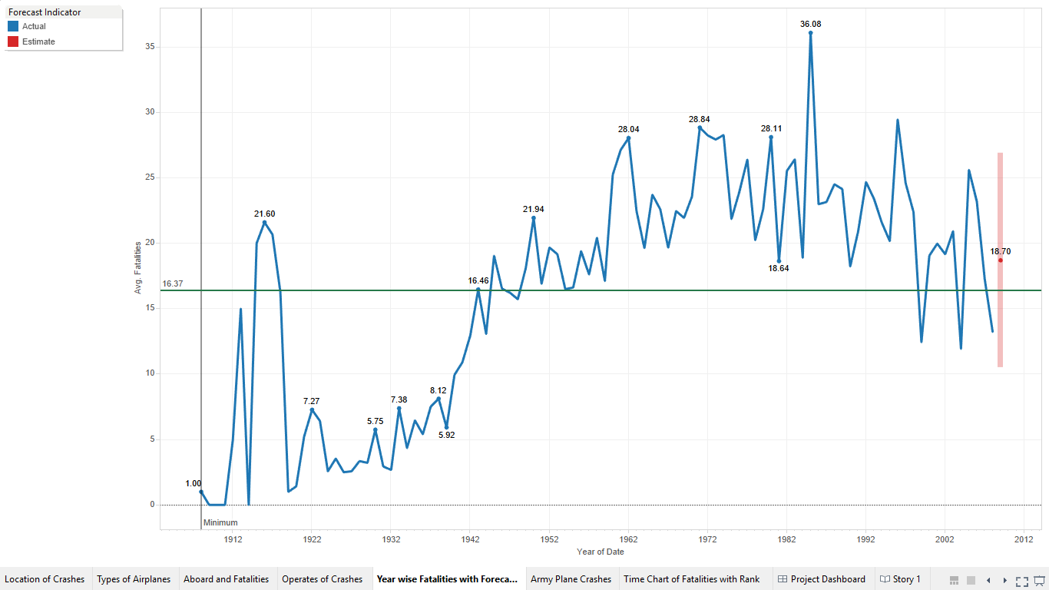

In the fifth visualization of the project, very interestingly we have projected the Average Fatalities with according to the year in the data set. According to the data 1985 had the maximum average of fatalities from the crashes with 36.08 fatalities in the corresponding year.

Most interesting inference from this part of the project is the forecast indicator which has made predication of the year one after what the data set has which is 2009. The area in red shows the future prediction with 18.70 average fatalities in the that year in reference to all the average fatalities in the previous years.

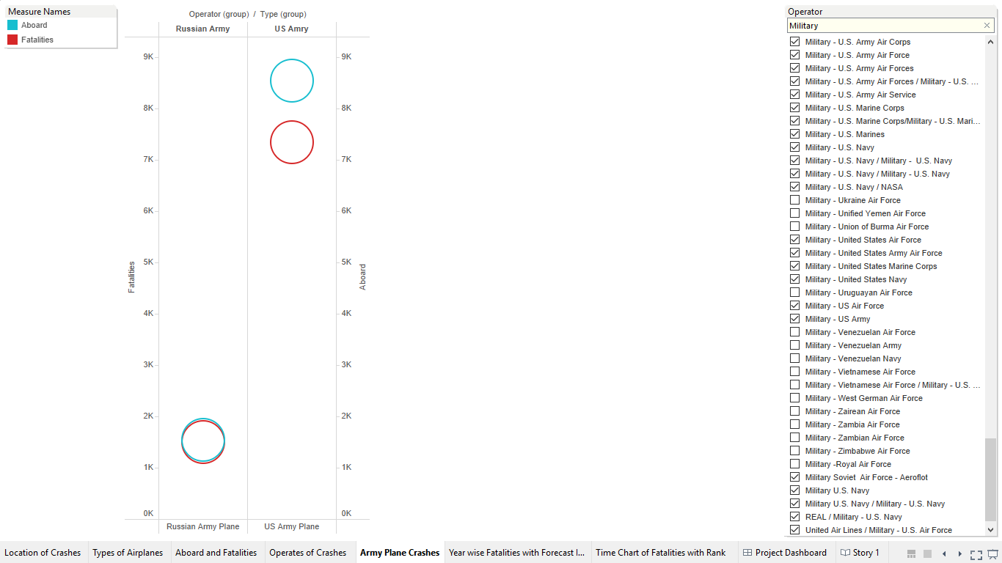6) Which out of the two US Army or Russian Army had more fatalities vs Aboard?

In the sixth visualization, it’s a dual axis with aboard and fatalities which have been sorted by operates and then different sections of US Armies and Russian Armies have been grouped together for the above visualization. In the data set US Army data is more hence the more visual it looks but it compares both the armies.

7) What is the Year wise Fatalities in terms of Type, Operate and Location of the crash?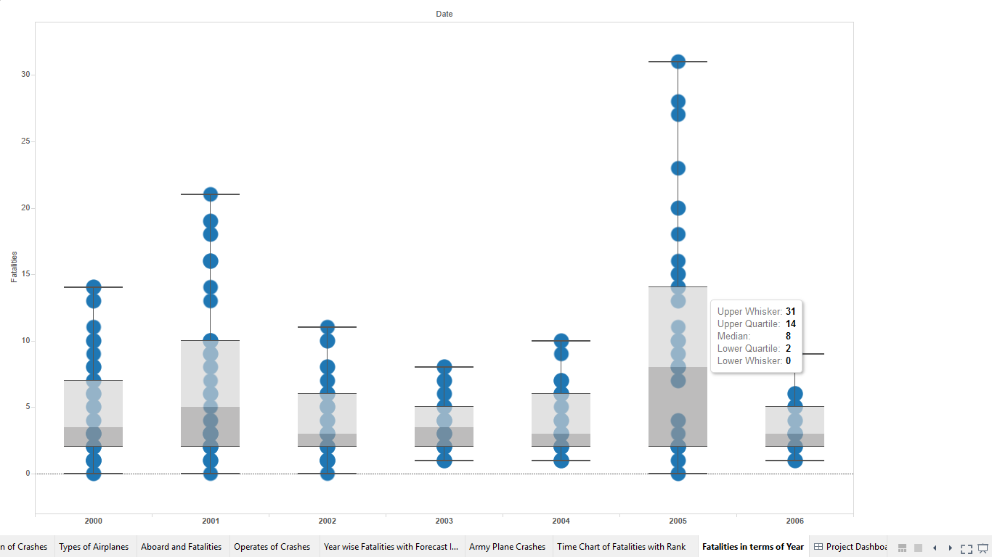

In the seventh and final visualization, analyzing the fatalities that have occurred from 2000-2006 in a Whisker-Box Plot Graph which shows us the average in terms of whisker and quartile where the median is the mid value and above that is values that are greater than those of the median.

For 2005, Sum of fatalities had a median value of 8 and there were 14 values greater than 25% of the median and 31 values were the maximum means the Upper Whisker.

## Dashboard

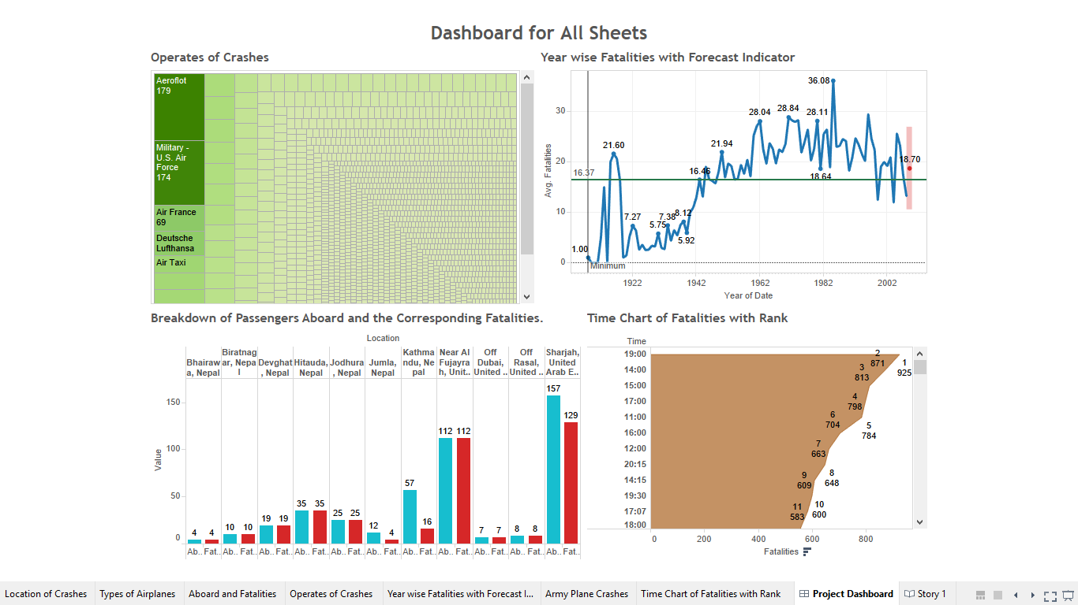

Here is the dashboard for the project with a new area bar chart in which specific time corresponding to the no of fatalities have occurred sorted by Rank. Others are the same charts from the Visualizations from above.

## Story Telling

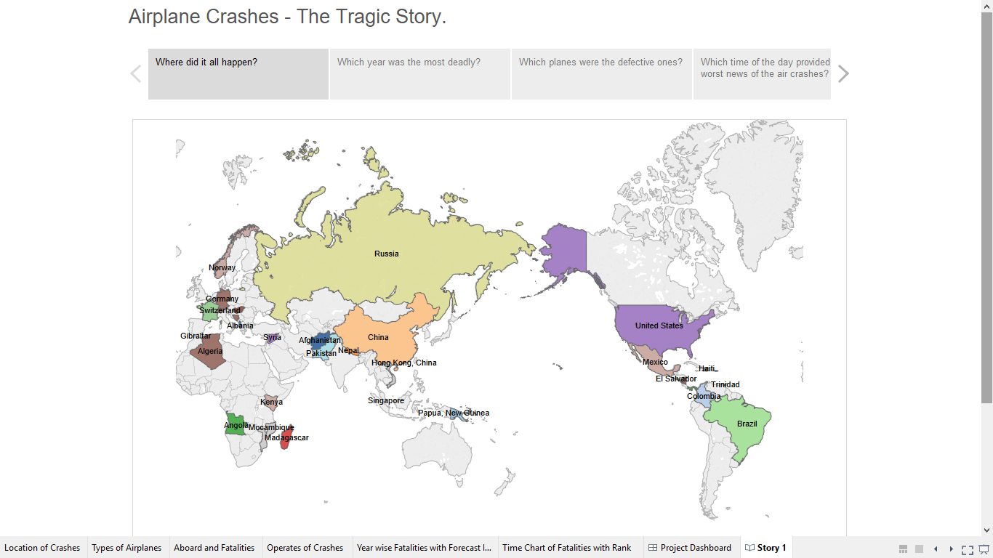

Airplane crashes are the most tragic stories in all of mankind as some innocent souls get on a plane to travel to either their home countries, to a business location or somewhere else not knowing what might be in the future. Thousands of miles away from the ground leaving your fate on the flight captain and others is something to be feared by and all this visualization shows how the fears actually do come true. Russia is one place where major plane crashes have occurred and is a place that in my project depicts the maximum crashes. According to an article by BBC News which talks about one of the crashes and is as follows;

“Two Russian airliners carrying 89 passengers and crew have crashed within minutes of each other after flying out of the same Moscow airport.

Witnesses at one scene said they heard a plane roaring overhead followed by "an explosion like thunder".

Russian President Vladimir Putin ordered the state security services, the FSB, to launch an investigation. An FSB spokesman said searches had revealed no signs of terrorism but sabotage had not been ruled out. There were speculations Chechen rebels were behind the attack, ahead of presidential elections in the republic on Sunday - but this has been denied by rebel leaders.

A spokesman from Moscow's Domodedovo airport said no foreigners were on either passenger list. The two planes flew out of the airport within 40 minutes of each other on Tuesday evening. Trouble was noticed with both flights almost simultaneously at about 2300 local time (1900 GMT).

BBC News (2004, August 24th) Double Air Disaster hits Russia. *BBC News.* Retrieved from <http://news.bbc.co.uk/2/hi/europe/3596354.stm>

This shows that airplane crashes in Russia were a major concern back in the days and had the majority of casualties as well.

There were many different types of airplanes back in the day which use to have faulty features and one major contender were the Douglas DC-3’s, Boeings and the Airbuses. The possibility of a crash heavily depends on a how the craft is made and maintained. Major security concerns are taken and numerous checks are done for the safety of the aircraft before take-off and in the mean time before the next flight takes over. The Douglas DC-3 was one of the focal points in World War II but is still commercial used in the flight circuit with great effect.

Just comparing the causalities in never a good way to look into any of the plane crashes and understanding the extent but it’s the best possible way to understand how bad the situation got out of hand at the last moment. Comparing two countries Nepal and United Arab Emirates, we found that there were several crashes that occurred in Nepal in the early 2000’s and also in U.A.E. Quoting an article about the plane crash in Sharjah a northern emirate in the country shows us the extend of the crash.

“A Kish Airlines flight crashed near Sharjah International Airport at 11.40am this morning, killing 43 of 46 people aboard the aircraft.  
The twin-engined Fokker 50 aircraft, flight IRK 1770, crashed 3km from the airport complex at the Sharjah-Ajman border.  
"The aircraft came down in Al Ramaqiah between two residential areas, initially crashing on a road before coming to rest in an uninhabited area," stated Dr Ghanem Al Hajri, director general, Sharjah Civil Aviation Authority.  
The scheduled flight was coming from Kish Island, and was on a 'visa change' run, he added. Thirty-eight were confirmed dead at the site, while two succumbed subsequently to their injuries at hospital. There were three survivors, while three others were still missing in the wreckage, he said” Abdullah Arbab and Shadiah Abdullah (2004, 10th February). 43 passengers died in Sharjah air crash. *Gulf News*. Retrieved from <http://gulfnews.com/news/uae/general/43-passengers-died-in-sharjah-air-crash-1.313211>

Brand name is important hence when you have to globally define yourself in this huge market of brand names of carriers or operates. Aeroflot has a huge brand name in the market of carriers but the analyzation shows that Aeroflot flights have the maximum deaths on the ground. Which means causalities have occurred after landing. Other carrier or operates that have their numbers high in ground deaths would be Air France and Deutsche Lufthansa.

US Army and Russian Army collided in the World War and hence the casualties of these armies were significantly very high. In majority over 8000 aboard were there in US Army planes and correspondingly over 7000 fatalities on the same issues. Whereas the Russian Army according to the data has over 1800 aboard on its flights and casualties are over 1700. One of the crashes recorded in an article is presented below.

“A huge AWACS battlefield-radar plane carrying 24 U.S. and Canadian military personnel crashed on takeoff and exploded in a fireball Friday, killing everyone aboard, authorities said. The bodies of 22 crew members were found, and searchers were looking for the remains of the other two Friday evening, said Maj. Jereon Brown, an Air Force spokesman at the base. It was the first crash of an Airborne Warning and Control System plane since the Air Force began using the aircraft in 1977. A source speaking on condition of anonymity said the crash may have been caused by about a dozen Canada geese found dead at the departure end of the runway. The Air Force would not speculate on a cause, and said a board of officers would investigate.

The plane exploded on impact about two miles from the end of the runway, deep in the woods in an area inaccessible to fire engines. Rescuers had to bulldoze a path to the site, which was marked by a plume of smoke that could be seen 30 miles away”.

Los Angeles Times (1995, 23rd September). 24 Killed as U.S AWACS Plane Crashes in Alaska. *Los Angeles Times.* Retrieved from: <http://articles.latimes.com/1995-09-23/news/mn-49141_1_air-force>.